Database Schema for a Employee-pay scenario

**employee(emp_id** : integer, emp_name: string)

**department(dept_id:** integer, dept_name:string)

**paydetails(**emp_id : integer, dept_id: integer, basic: integer, deductions: integer, additions: integer, DOJ: date)

**payroll**(emp_id : integer, pay_date: date)

1. **Create table query:**

**create a table for employee17**

create table employee17(emp_id number(4)primary key,emp_name varchar2(20));

**output:**

Table created.

0.06 seconds

**Describe emplyee17**

desc employee17;

**output:**

|  |  |  |  |
| --- | --- | --- | --- |
| Object Type | **TABLE** | Object | **EMPLOYEE17** |

|  |
| --- |
|  |

| **Table** | **Column** | **Data Type** | **Length** | **Precision** | **Scale** | **Primary Key** | **Nullable** | **Default** | **Comment** |
| --- | --- | --- | --- | --- | --- | --- | --- | --- | --- |
| [EMPLOYEE17](javascript:ret_Column('BAGAVATHY.EMPLOYEE17');) | [EMP_ID](javascript:ret_Column('EMP_ID');) | NUMBER | - | 4 | 0 | 1 | - | - | - |
|  | [EMP_NAME](javascript:ret_Column('EMP_NAME');) | VARCHAR2 | 20 | - | - | - | nullable | - | - |

**Create a table for department17**

create table department17(dept_id number(4)primary key,dept_name varchar2(10));

**output**

Table created.

0.08 seconds

**Describe department17**

desc department17;

**output:**

| **Table** | **Column** | **Data Type** | **Length** | **Precision** | **Scale** | **Primary Key** | **Nullable** | **Default** | **Comment** |
| --- | --- | --- | --- | --- | --- | --- | --- | --- | --- |
| [DEPARTMENT17](javascript:ret_Column('BAGAVATHY.DEPARTMENT17');) | [DEPT_ID](javascript:ret_Column('DEPT_ID');) | NUMBER | - | 4 | 0 | 1 | - | - | - |
|  | [DEPT_NAME](javascript:ret_Column('DEPT_NAME');) | VARCHAR2 | 10 | - | - | - | nullable | - | - |

**Create a table for paydetails17**

create table paydetails17(emp_id number(4) references employee17(emp_id),dept_id number(4) references department17(dept_id),basic number(5),deduction number(3),addition number(3),doj date);

**output:**

Table created.

0.03 seconds

**Describe paydetails17:**

desc paydetails17;

**output:**

|  |  |  |  |
| --- | --- | --- | --- |
| Object Type | **TABLE** | Object | **PAYDETAILS17** |

|  |
| --- |
|  |

| **Table** | **Column** | **Data Type** | **Length** | **Precision** | **Scale** | **Primary Key** | **Nullable** | **Default** | **Comment** |
| --- | --- | --- | --- | --- | --- | --- | --- | --- | --- |
| [PAYDETAILS17](javascript:ret_Column('BAGAVATHY.PAYDETAILS17');) | [EMP_ID](javascript:ret_Column('EMP_ID');) | NUMBER | - | 4 | 0 | - | nullable | - | - |
|  | [DEPT_ID](javascript:ret_Column('DEPT_ID');) | NUMBER | - | 4 | 0 | - | nullable | - | - |
|  | [BASIC](javascript:ret_Column('BASIC');) | NUMBER | - | 5 | 0 | - | nullable | - | - |
|  | [DEDUCTION](javascript:ret_Column('DEDUCTION');) | NUMBER | - | 3 | 0 | - | nullable | - | - |
|  | [ADDITION](javascript:ret_Column('ADDITION');) | NUMBER | - | 3 | 0 | - | nullable | - | - |
|  | [DOJ](javascript:ret_Column('DOJ');) | DATE | 7 | - | - | - | nullable | - | - |

**Create a table for payroll17**

create table payroll17(emp_id number(4) references employee17(emp_id),paydate date);

**output:**

Table created.

0.06 seconds

**Describe payroll17**

desc payroll17;

**output:**

|  |  |  |  |
| --- | --- | --- | --- |
| Object Type | **TABLE** | Object | **PAYROLL17** |

|  |
| --- |
|  |

| **Table** | **Column** | **Data Type** | **Length** | **Precision** | **Scale** | **Primary Key** | **Nullable** | **Default** | **Comment** |
| --- | --- | --- | --- | --- | --- | --- | --- | --- | --- |
| [PAYROLL17](javascript:ret_Column('BAGAVATHY.PAYROLL17');) | [EMP_ID](javascript:ret_Column('EMP_ID');) | NUMBER | - | 4 | 0 | - | nullable | - | - |
|  | [PAYDATE](javascript:ret_Column('PAYDATE');) | DATE | 7 | - | - | - | nullable | - | - |

1. **INSERT QUERY:**

**Insert records into employee17**

insert into employee17 values(101,'keerthi');

1 row(s) inserted.

0.06 seconds

insert into employee17 values(102,'mani');

insert into employee17 values(103,'ranga');

insert into employee17 values(104,'vinoj');

insert into employee17 values(105,'dinesh');

**view employee17**

select * from employee17;

**output:**

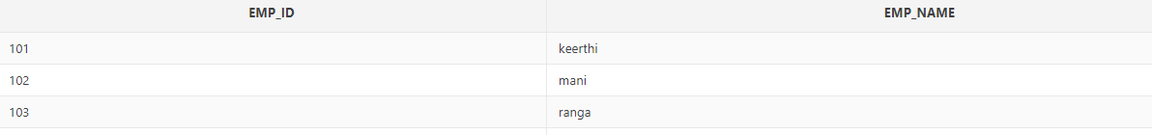



**Insert records into department17**

insert into department17 values(10,'EB');

insert into department17 values(11,'twad board');

insert into department17 values(12,'highway');

insert into department17 values(13,'agricul');

insert into department17 values(14,'treasury');

select * from department17;

**output:**



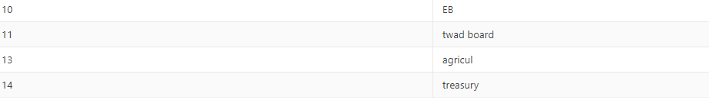

**Insert records into paydetails17**

insert into paydetails17 values(101,11,12000,300,450,'12-2-1999');

insert into paydetails17 values(102,10,22000,900,500,'4-15-1996');

insert into paydetails17 values(104,13,8000,100,600,'3-3-2017');

insert into paydetails17 values(103,12,35000,999,600,'12-25-2001');

insert into paydetails17 values(105,14,20000,800,200,'10-30-2009');

**view paydetails17**

select * from paydetails17;

**output:**



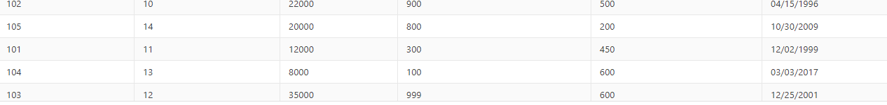

**Insert records into payroll17**

insert into payroll17 values(101,'1-14-2019');

insert into payroll17 values(102,'5-21-2019');

insert into payroll17 values(103,'10-12-2019');

insert into payroll17 values(102,'7-24-2019');

insert into payroll17 values(104,'12-29-2019');

**view payroll17**

select * from payroll17;

**output**:



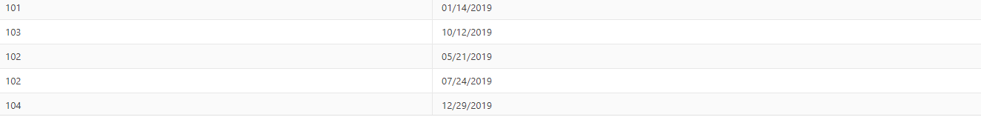

1. **List the employee details department wise:**

select d.dept_id, e.emp_id,e.emp_name from employee17 e,department17 d,paydetails17 p where e.emp_id=p.emp_id and d.dept_id=p.dept_id;

**output:**

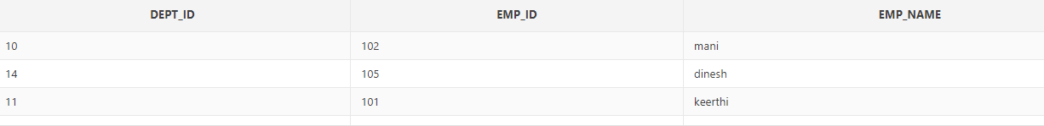



1. **List all the employee names who joined after particular date:**

select e.emp_name from employee17 e,paydetails17 p where e.emp_id=p.emp_id and p.doj>='1-1-2000';

**output:**

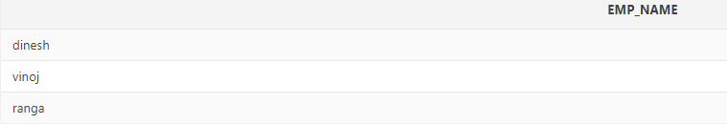

1. **List the details of employees whose basic salary is between 10000 and 20000**

Select e.emp_id,e.emp_name from employee17 e,paydetails17 p where e.emp_id=p.emp_id and basic between 10000 and 20000;

**Output:**



1. **Give a count of how many employees are working in each department**

select count(emp_id),dept_id from paydetails17 group by dept_id;

**output:**

|  |  |
| --- | --- |
| COUNT(EMP_ID) | DEPT_ID |
| 1 | 11 |
| 1 | 13 |
| 1 | 14 |
| 1 | 10 |
| 1 | 12 |
|  |  |

1. **List the details for an employee_id=105**

select * from employee17 where emp_id=105;

**output:**

|  |  |
| --- | --- |
| EMP_ID | EMP_NAME |
| 105 | dinesh |
|  |  |

1. **Give a names of the employees whose netsalary>13000**

**Alter paydetails17 table:**

alter table paydetails17 add netsal number(10);

**output:**

Table altered.

0.13 seconds

**View paydetails17 table:**

|  |  |  |  |
| --- | --- | --- | --- |
| Object Type | **TABLE** | Object | **PAYDETAILS17** |

|  |
| --- |
|  |

| **Table** | **Column** | **Data Type** | **Length** | **Precision** | **Scale** | **Primary Key** | **Nullable** | **Default** | **Comment** |
| --- | --- | --- | --- | --- | --- | --- | --- | --- | --- |
| [PAYDETAILS17](javascript:ret_Column('BAGAVATHY.PAYDETAILS17');) | [EMP_ID](javascript:ret_Column('EMP_ID');) | NUMBER | - | 4 | 0 | - | nullable | - | - |
|  | [DEPT_ID](javascript:ret_Column('DEPT_ID');) | NUMBER | - | 4 | 0 | - | nullable | - | - |
|  | [BASIC](javascript:ret_Column('BASIC');) | NUMBER | - | 5 | 0 | - | nullable | - | - |
|  | [DEDUCTION](javascript:ret_Column('DEDUCTION');) | NUMBER | - | 3 | 0 | - | nullable | - | - |
|  | [ADDITION](javascript:ret_Column('ADDITION');) | NUMBER | - | 3 | 0 | - | nullable | - | - |
|  | [DOJ](javascript:ret_Column('DOJ');) | DATE | 7 | - | - | - | nullable | - | - |
|  | [NETSAL](javascript:ret_Column('NETSAL');) | NUMBER | - | 10 | 0 | - | nullable | - | - |

**Update**

update paydetails17 set netsal=basic+addition;

**output :**

5 row(s) updated.

0.02 seconds

**Now ,check for the netsal >13000**

select e.emp_id,e.emp_name,p.netsal from paydetails17 p,employee17 e where e.emp_id=p.emp_id and netsal>=13000 ;

**output :**

|  |  |  |
| --- | --- | --- |
| EMP_ID | EMP_NAME | NETSAL |
| 102 | mani | 22500 |
| 103 | ranga | 35600 |
| 105 | dinesh | 20200 |

1. **Create a view which lists out the emp_name, department, basic, deduction,netsalary**

create view viemployee17 as(select e.emp_name,d.dept_name,p.basic,p.deduction,p.netsal from employee17 e,paydetails17 p,department17 d where e.emp_id=p.emp_id and d.dept_id=p.dept_id);

**output:**

View created.

0.06 seconds

**View vemployee17**

select * from viemployee17;

**output:**

|  |  |  |  |  |
| --- | --- | --- | --- | --- |
| EMP_NAME | DEPT_NAME | BASIC | DEDUCTION | NETSAL |
| keerthi | twad board | 12000 | 300 | 12450 |
| mani | EB | 22000 | 900 | 22500 |
| ranga | highway | 35000 | 999 | 35600 |
| vinoj | agricul | 8000 | 100 | 8600 |
| dinesh | treasury | 20000 | 800 | 20200 |

1. **Create a view which lists the emp_name and his netsalary:**

create view vlemp17 as(select e.emp_name,p.netsal from employee17 e,paydetails17 p,department17 d where e.emp_id=p.emp_id and d.dept_id=p.dept_id);

**view viewlist17**

select * from vlemp17;

**output:**

|  |  |
| --- | --- |
| EMP_NAME | NETSAL |
| keerthi | 12450 |
| mani | 22500 |
| ranga | 35600 |
| vinoj | 8600 |
| dinesh | 20200 |